Website Re-Design

Michael Brousseau

Jake Charlebois

11/19/15

For this assignment I chose to re-design my father’s IT/Computer maintenance website “RLC Networx.com” I chose this website because I thought it would be useful to my father to have an updated website design, and I also thought that it would be helpful for myself in the sense that I would be able to take the assignment to very creatively flexible heights. This write up will be separated into the following Three major categories: Colour, Design Principles and Accessibility, and Personal Preferences.

**Colour**

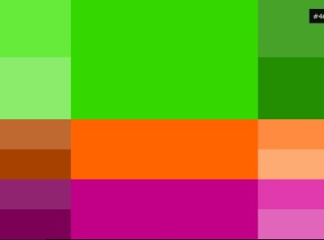As is roughly depicted in the second wireframe, t he colour scheme for this particular website will revolve around shaded of greens. These greens will be light and de-saturated, between a balance of being pleasing to the eye so as to not be too harsh or vibrant, and being the right hue so as to not appear ugly or dismal. (ie. the colour affiliated with vomit). The links will be a hue of magenta/violet and the illustrations of the page will lean towards an orange colour correction so as to correlate with a triad colour scheme roughly based on the following illustration. Where possible, gradients from a darker green to a lighter green will be used to impose a sense of modernism. Ultimately the colour scheme was decided upon in the hopes that it would be associated with the colour of circuit boards, thus acting as a significant connection between the design and the content of the website.

**Design Principles and Accessibility**

Based on the C.R.A.P principles of design (Contrast, Repetition, Alignment and Proximity) it was decided that the Navigation would be separated into two major parts; general and content specific. The general navigation would be placed at the top of the page with the home page and links to “about us” and “contact information” on the left hand side of the page with content specific links which are clearly categorized into computer and networking. This navigation structure would have the motif of being inside light green boxes with a darkest green border and a dark green background, where as the content and reading material would be inside a white box on the right hand/middle of the page to establish clear contrast. This navigation “upside-down-L” structure would also be positioned to only scroll up to the top of the page and then remain fixed. This was decided upon for ease of access purposes; so that the links to the content of the page could always be reached from the user’s current position. All of these elements will of course be properly aligned and will be given consistent margining and padding to give way to proximity and placement orders.

**Personal Design Preferences**

As a personal challenge, I will be creating the graphics for this website from scratch using my camera and colour correcting them in Photoshop. I will be integrating a selection of graphics to fade from one to the next on the home page so as to create an aesthetically exciting home page. I will be redesigning the logo to be at a higher quality and resolution, and will attempt to have it as a flash animation that fades in similar to its current design, but to also include electricity (small white “blips”) flowing down circuitry (this element will be on a loop that resets to a point after the initial fade in). I will attempt to accomplish these additions through a combination of Flash Actionscript and Javascript.